**Working with Custom DLLs in SSRS:**

**Requirements:**

1. Make sure the DLL AssemblyInfo:

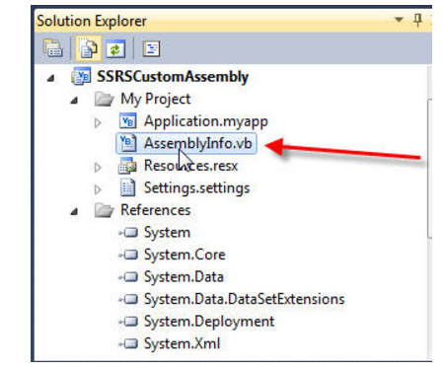

… Has the following tag:

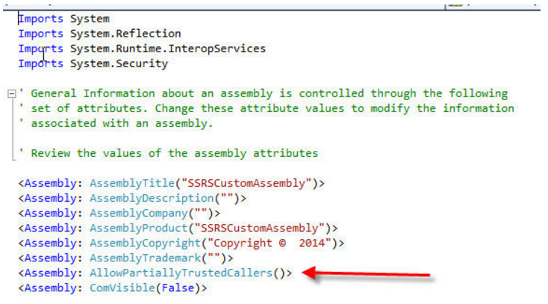

1. While testing locally on the client side, add the custom DLL to the GAC.

**Using the DLL on the SSRS report designer side:**

Click on the Report properties contextual menu:

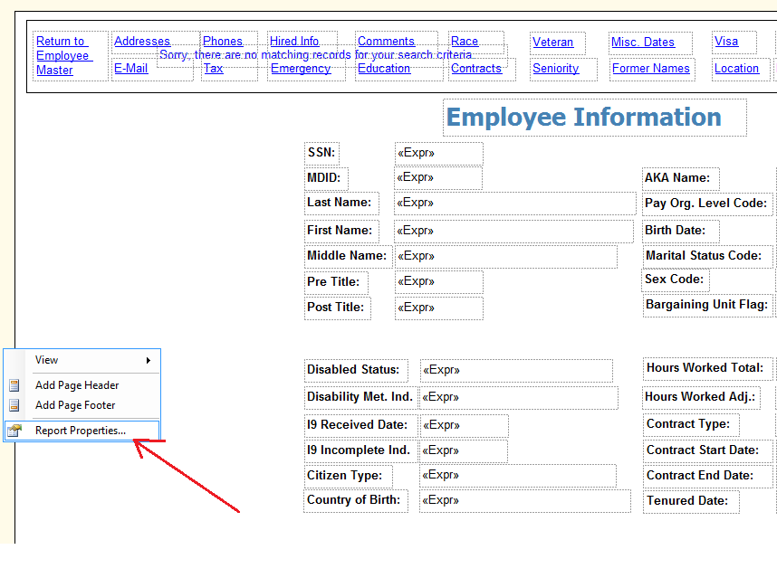

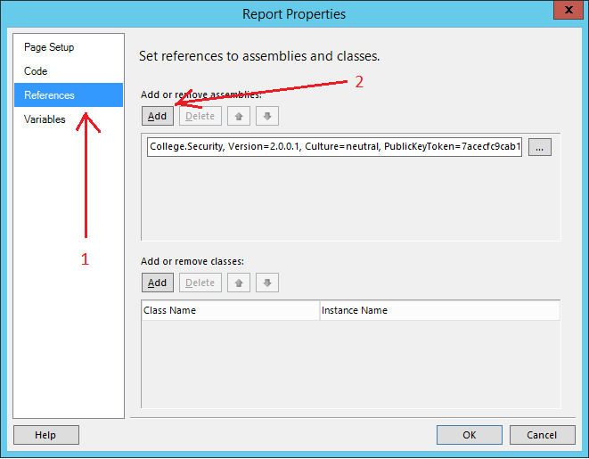

Let’s say we want to make a specific textbox visible or hidden, using the DLL we built and added to the Report references. Right click on the text box, contextual menu “Text Box properties”:

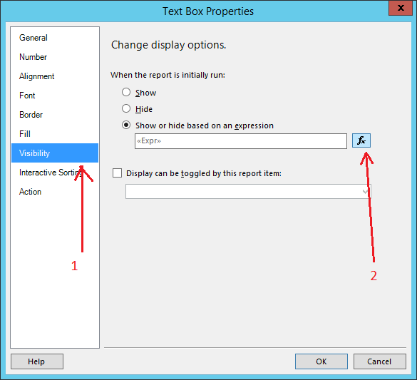

For using the DLL, we can write the following expression:

=Not College.Security.UserTools.IsCurrentUserInGroup("Z_PayStub_ViewOtheEmployeesPaystub")

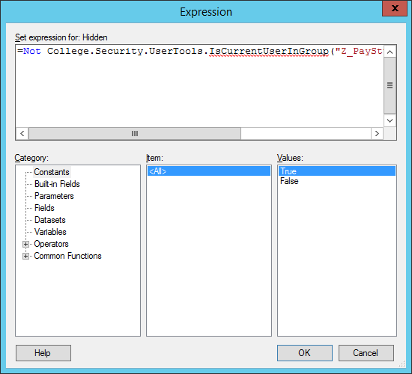

**Deploying the DLL on the SSRS Report Server side**

1. Copy the custom DLL and its dependencies (other custom DLLs referenced from the first one) to:

"C:\Program Files\Microsoft SQL Server\**SSRSVerioningFolder**\Reporting Services\ReportServer\bin"

1. Modify the rssrvpolicy.config in ReportServer folder, find "$CodeGen$" and add the following code. For instance, if we are going to add College.Security DLL, because it depends too from College and College.Text, then we need to add the following:

<CodeGroup

    class="UnionCodeGroup"

    version="1"

    PermissionSetName="FullTrust"

    Name="College.Security"

    Description="MDC College.Security library">

        <IMembershipCondition class="UrlMembershipCondition"

        version="1"

        Url=" C:\Program Files\Microsoft SQL Server\MSRS10.MSSQLSERVER\Reporting Services\ReportServer\bin\College.Security.dll"

        />

</CodeGroup>

<CodeGroup

    class="UnionCodeGroup"

    version="1"

    PermissionSetName="FullTrust"

    Name="College"

    Description="MDC College library">

        <IMembershipCondition class="UrlMembershipCondition"

        version="1"

        Url="C:\Program Files\Microsoft SQL Server\MSRS10.MSSQLSERVER\Reporting Services\ReportServer\bin\College.dll"

        />

</CodeGroup>

<CodeGroup

    class="UnionCodeGroup"

    version="1"

    PermissionSetName="FullTrust"

    Name="College.Text"

    Description="MDC College.Text library">

        <IMembershipCondition class="UrlMembershipCondition"

        version="1"

        Url="C:\Program Files\Microsoft SQL Server\MSRS10.MSSQLSERVER\Reporting Services\ReportServer\bin\College.Text.dll"

        />

</CodeGroup>